|  |  |
| --- | --- |
|  |  |

Ingegneria del Software e Progettazione Web

Progetto A.A. 2022/2023

SPORTIFY

Chiara D’Ambrogio

Matteo La Gioia

**Indice**

1. Software Requirement Specification 3

1.1. Introduction 3

1.1.1. Aim of the document 3

1.1.2. Overview of the defined system 3

1.1.3. Operational settings 3

1.1.4. Related systems 4

1.2. User Stories 4

1.3. Functional Requirements 5

1.4. Use Cases: Overview Diagram 6

2. Storyboards 7

2.1. Format: HTML 7

2.2. Screens 7

3. Design 8

3.1. Class diagram 8

3.2. Design patterns 8

3.3. Activity diagram 8

3.4. Sequence diagram 8

3.5. State diagram 8

4. Testing 9

4.1. Test Cases 9

4.2. Test Selenium GUI 9

4.3. Test Selenium API 9

5. Code 10

5.1. ~4K LOC 10

5.2. Similar functionality implemented with GUIs. 10

5.3. Exceptions 10

5.4. Svn (or Git) + SonarCloud 10

5.5. DAO 10

6. Analytics 11

7. Video 12

# Software Requirement Specification

## Introduction

### Aim of the document

The project aims to encourage people to practice a sport helping them choose the best sport for them and the gym where to practice it.

### Overview of the defined system

Sportify is mainly used by users to search for courses and gyms and for the latter also leave reviews on their service, while by gyms mainly to be able to add courses and schedules of the latter to their Sportify profile, now let's describe the guaranteed features:

* User:
* Search for sports
* Fill out the test to understand the sport that best suits you
* Find your nearest gym
* Writing reviews for popular gyms
* Gyms:
  + Add courses and timetables for these last
  + Read reviews for your gym
  + Delete possible unconstructive reviews

### Operational settings

There are many operating settings for Sportify; mainly the program will be used mobile application or computer program by: users looking for courses or gyms, users who want to understand the most suitable sport for them and gyms that want to advertise themselves to users.

For the development of the software, we used:

* Figma.com to get the HTML code of the storyboards.
* Star UML for the realization of diagrams related to the design of the system
* Scene Builder for creating FXML files to create the graphical interface (MVC views)
* JavaFX to manage and extend FXML files (MVC graphics controller)
* IntelliJ and especially Java as IDE and programming environment. To use the software, you must extract the Sportify folder from the zip file and open it as a project in IntelliJ. In the folder there is already the .idea file to configure how to run the application. If this is not possible, the class with the responsibility for starting the application is MainAppLauncher.java.

### Related systems

(at least 2), Pros and Cons.

Making a careful analysis of the competitors, although similar services are few, we have identified the two in particular: *nome1*, *nome2*.

• *Nome1*: *Cosa offre, in cosa è meglio Sportify*.

• *Nome2*: *Cosa offre, in cosa è meglio Sportify*.

## User Stories

(3 per member)

**• As a new user, I want to discover which sport suits me and my needs best, so that I can start practicing it.**

**• As a user, I want to review my experience in a gym, so that it could be useful for other users.**

**• As a gym owner, I want to know which are the 10 most practiced sports in Italy, so that I can add them to my gym offer.**

**• As a new user, I want to know which are the gym with a selected sport in a range of choices, so that I do not waste time moving.**

**• As a user, I want to know the main information about a selected sport, so that I can decide whether to practice it or not.**

**• As a gym, I want to sponsor myself, so that I get greater visibility.**

• As a gym owner, I want to read the reviews made about my gym, so that I can modify and improve my gym offer.

• As a user, I want to keep note of which level I reached in the sports I practice, so that I can constantly improve myself.

## Functional Requirements

(3 per member)

• **The system, based on specific questions, shall decide the best sport for the user’s needs.**

**• The system shall provide the possibility to read the reviews users made.**

**• The system shall provide all the gyms in a range of choice from a chosen location, in which they can practice the selected sport.**

**• The system shall create a list of the ten most practiced sports in Italy based on how many times a sport has been chosen.**

**• The system shall provide the main information about a selected sport.**

**• The system shall send an alert to the user who is searching for a particular sport, from the gyms that offer that sport and that is in a range of choice from a selected location**

• The system shall keep track of the level the user reaches in each sport.

• The system shall provide to review user’s experience in the gyms by adding a comment in the appropriate box on the gyms profile pages.

## Use Cases: Overview Diagram

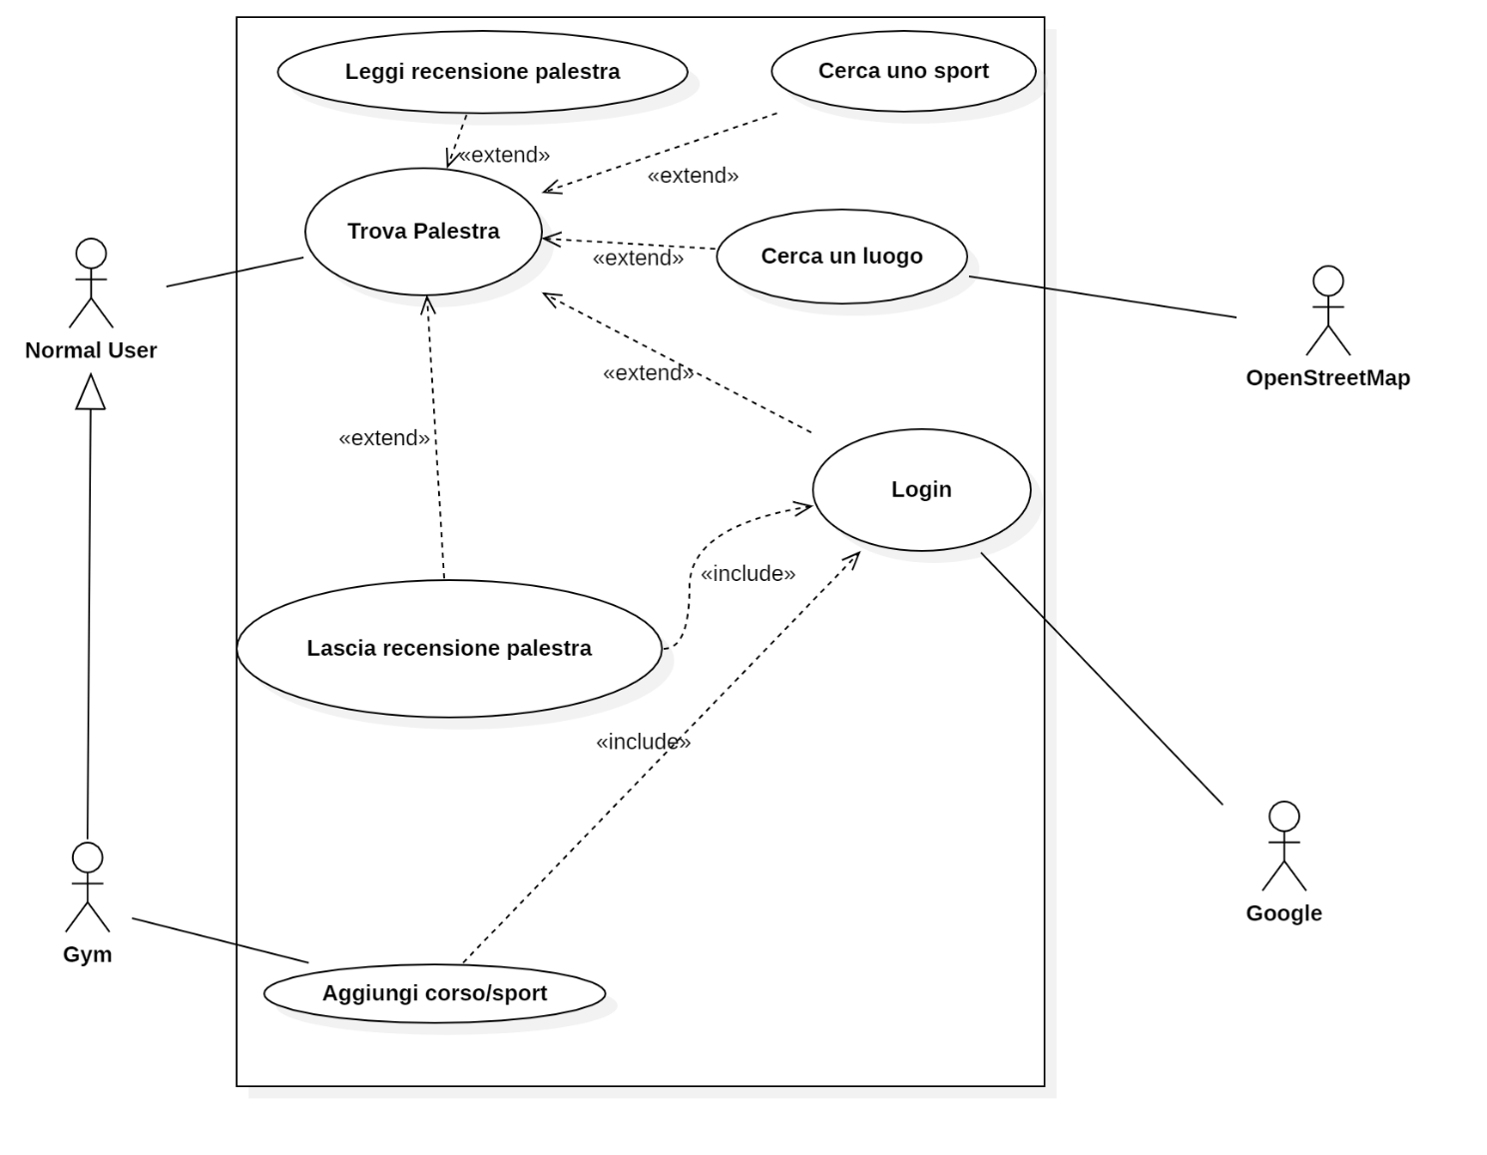

# Storyboards

## Format: HTML

## Screens

Quantity: 2 screens per member, covering all the functionalities described in SRS, developed using Draw.io or similar

# Design

## Class diagram

* 1 VOPC per member. (analysis)
* 1 design-level diagram per member (e.g. that includes patterns, or specific solutions that improve the engineering level of the system)

## Design patterns

1 different pattern per member. Possibly try to apply the pattern within the context of the project.

## Activity diagram

1 per member.

## Sequence diagram

1 per member.

## State diagram

1 per member.

# Testing

## Test Cases

Develop at least 3 test cases per person. In each test (class) file, please report (via Java comments) the name of the person in charge.

## Test Selenium GUI

1 Selenium test via GUI per member.

## Test Selenium API

1 Selenium test via API per member.

# Code

## ~4K LOC

## Similar functionality implemented with GUIs.

## Exceptions

at least 2 per member (do not just catch and back-propagate the exceptions, but properly handle them. Possibly define your own error logic by means of exceptions)

## Svn (or Git) + SonarCloud

Be able to show that Svn (or Git) + SonarCloud is correctly installed in one of your computer and it can analyse your project for rule violations. No rule must be violated (no smells, no vulnerabilities, no bugs. This will be checked during the exam.

## DAO

One DAO shall be provided in two versions DMBS and file system.

# Analytics

Provide a Process Control Chart as explained in the slides.

# Video

A 1 to 2 minutes recorded video of the developed system performing the expected functionalities. *.mpeg